**CHAPTER THREE**

**SYSTEM ANALYSIS AND METHODOLOGY**

**3.1 SYSTEM ANALYSIS**

System Analysis is a method of the operation of a system with an attempt to bring out the basic problem area. It decides only when the system is not working properly. The system analysis is the process of analyzing or evaluating an existing system to find out how it works and how it meets the user needs. In order words it’s a technique that helps to describe and obtain facts and detects its pattern. Building such system is not an easy process but requires certain skills and capabilities.

**3.1.1 PRATICAL ANALYSIS OF THE EXISTING SYSTEM**

The present cafeteria management system is not online and paper based. The payment and process takes a lot of time as the customer has to pay the exact amount and wait for the change. If the change is not available at the time, a coupon is provided which should be shown at the counter at the next purchase. The cafeteria executive has to store this record in the registers for totaling and verification purpose. The cash at the end of the day have to be kept safe.

Advantage of the existing system:

1. Low cost.
2. Requires minimum cost.

Disadvantage of the existing system:

1. Needs lot of paperwork.
2. Problem with easy retrieval of data file
3. Customers queuing for long.

**3.1.2 DATA GATHERING**

This section explains different means by which information and data were gathered and collected to help analyze the existing system so that a clear description of the proposed system can be made. Data analysis is a practice in which raw data is ordered and organized so that useful information can be extracted from it. The process of organizing and thinking about data is the key to understanding what data does and does not contain. There are a variety of ways in which people can approach data analysis for this reason, it is important to pay attention when data analysis is presented, and to think critically about the data and the conclusions which were drawn. Charts, graphs and textual write-ups of data are all forms of data analysis. Summarizing data is often critical to supporting arguments made with that data, as it presents the data in a clear and understanding way. The methods used to collect data are: Oral interview and Study of manuals.

1**. Oral Interview:** The interview method of data collection can be defined as a systematic way of collecting data or information from a respondent through asking questions directly from the respondent and also collecting information with the aim of facilitating understanding. The oral interview was done between the researcher and the management of a staff of a cafeteria in Lagos. Reliable facts were gotten based on the questions posed to the staff by the researcher which helped me in starting the work and also helped in the area of solution presentation of the new design.

**2. Study of Manuals:** Manuals and report based on cafeteria services were obtained and studied and a lot of information concerning the system to be produced was obtained.

**3.1.3 LIMITATIONS OF THE EXISTING SYSTEM:**

The existing system has the following limitations:

i. The items on the menu are out of stock sometimes, but the employee doesn’t know about it which wastes time and sometimes create confusion as well.

ii. Since the existing system is also paper based it has a big disadvantage of data integrity, calculations have to be done manually and the data can be easily manipulated or lost.

**3.2 ANALYSIS OF THE PROPOSED SYSTEM**

The proposed system is developed to manage ordering activities in a cafeteria. It helps to record customer submitted orders. The system should cover the following functions in order to support the cafeteria’s business process for achieving the objectives:

1. To allow the customer to make order, view order and make changes before submitting their order and allow them make the payment.

2. To provide interface that allows promotion and menu.

3. To provide interface that shows customers’ orders detail to front-end and kitchen staffs for delivering customers’ orders.

4. A tool that allows the management to modify the food information such as price, add a new menu and many others as well as tools for managing user, system menu and promotion records.

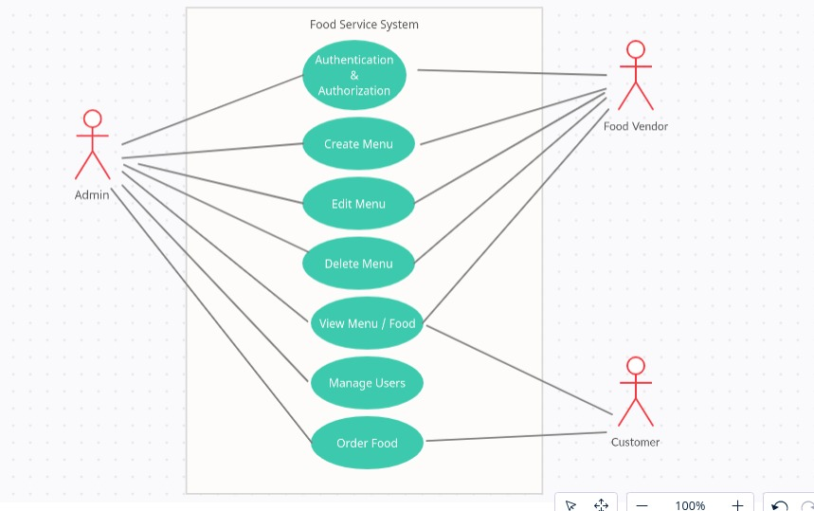

Figure 1.1 A use case diagram of the proposed system

Figure 1.1 is a use case diagram for the proposed cafeteria service system. The admin in the cause of accessing the system is expected to perform the following activities as specified in figure 1.1:

i. The system verifies the user by authenticating the inputs

ii. On successful authentication, the admin has the full privilege to create menu, edit menu,

delete menu, view menu, manage users and also order food.

The food vendor also has the privileges to create menu, edit menu, delete menu and view menu. While the customer has only two privileges which is to view menu and order food.

**3.3 METHODOLOGY**

A methodology is a formalized approach to implementing the System Development Life Cycle (SDLC) that is a list of steps and deliverables. There are many different system development methodologies and each one is unique because of its emphasis on the process versus data and the order and focus it places on each SDLC phase.

The methodology adopted for this work is the **Prototype Methodology**. It is a software development model in which prototype is built, tested, and reworked until an acceptable prototype is achieved. It also creates base to produce the final system or software. It works best in scenarios where the project’s requirements are not known in detail. It is an iterative, trial and error method which takes place between developer and client. The goal is to provide a system with overall functionality.